Citygreen™ STRATAVAULT ™
OPERATIONS AND MAINTENANCE MANUAL

Stratavault Operation and Maintenance Manual
TABLE OF CONTENTS
1.0 Introduction
1.1 Purpose
1.2 Permit Requirements

2.0 Maintaining Stratavault
2.1 Key Component Design Function and Maintenance Considerations
2.1.1 Inlet system
2.1.2 Distribution Pipe
2.1.3 Irrigation Systems
2.1.4 Stratavault Modular Units
2.1.5 Soil Media
2.1.6 Underdrain Pipe and Flow Control Devices
2.1.7 Trees / Vegetation
2.1.8 Surface Treatment
2.2 Maintenance Guidelines

3.0 Repairing Stratavault

Appendix A Method Statement for Pavement Opening, Repair and Reinstatement
Appendix B Citygreen Warranty

Stratavault Operation and Maintenance Manual
1.0 Introduction
Stratavault are a modular suspended pavement system that provides soil volume to support large tree growth and provides stormwater management through interception, storage, evapotranspiration, and pollutant uptake. When filled with soil media of suitable depth and quality, Stratavault also promote filtration of stormwater runoff through the soil media and infiltration of treated runoff into native site soils, making them a versatile Low Impact Development (LID) Best Management Practice (BMP).
The Washington State Department of Ecology has approved Stratavault as functionally equivalent to bioretention (Ecology 2013a). This approval allows designers in Washington State to design Stratavault to fully or partially satisfy minimum stormwater requirements for LID, water quality treatment, and flow control in accordance with the National Pollutant Discharge Elimination System (NPDES) Municipal Separated Storm Sewer System (MS4) permit (NPDES stormwater permit).
When Stratavault are installed as part of a permanent stormwater management system to meet stormwater permit requirements, they should be maintained as required by the local jurisdiction for maintenance of stormwater and LID BMPs.
The remainder of this section discusses the purpose of this document, applicable permit requirements, how this manual is intended to be used, and important definitions.
1.1 Purpose
This document provides guidance to assist owners and operators of Stratavault facilities with planning and implementation of maintenance to promote long-term system performance in accordance with the design intent. These recommendations should be considered as general guidelines, not requirements, and they should be reviewed and adapted as appropriate to develop site-specific maintenance plans based on the specific design configuration of a given site.
1.2 Permit Requirements
Stratavault may be designed and installed as LID BMPs that fully or partially satisfy applicable soil and/or stormwater requirements for new or redevelopment projects. Check the local permit requirements to determine whether such requirements apply to your project.
While Stratavault can be designed as LID BMPs, they can also be used to promote large, healthy trees in dense urban environments, without the intent of formally managing stormwater runoff. In such cases, stormwater permit requirements would not apply.

2.0 Maintaining Stratavault
This section identifies key component design functions and maintenance considerations, provides guidance on inspection and maintenance activities and recommended frequencies, lists needed equipment and materials, and discusses skills and staff needed to perform the recommended maintenance.
2.1 Key Component Design Function and Maintenance Considerations
Key components of the Stratavault system include the inlet structures, distribution pipes, the modular Stratavault units and frames, fill soils, underdrain pipe, flow control structures, trees/vegetation, and surface treatments. Intended general design functions and maintenance considerations for each of these key components are discussed below.
2.1.1 Inlet system
Stratavault inlet systems can be designed to allow stormwater runoff to flow into the facility in a number of ways. Water can sheet flow from adjacent hardened surfaces, infiltrate via overlying or adjacent permeable surfaces, flow through curb cuts, or be piped from a catch basin, roof drains, or yard drains.
However the inlet system(s) are configured, they must be properly sized and maintained to allow stormwater runoff from the intended contributing drainage area to enter the facility. Key maintenance considerations include providing pre-treatment through temporary erosion and sedimentation control measures in the tributary drainage basin during construction and long-term pre-treatment through stabilization of open soil areas in the tributary basin with plants or mulch and maintenance of inlet capacity by removing sediment, trash, and debris from inlets, sediment capture forebays and the contributing drainage area.
2.1.2 Distribution Pipe
Some installations may include a distribution pipe to distribute inflows across the surface of the facility. Distribution pipes are typically 4- to 8-inch-diameter (100- to 200-millimeter-diameter) perforated or slotted pipes installed on top of or within the soil media. Maintenance activities should preserve the ability of the pipe to distribute the water effectively by removing clogs and repairing or replacing cracked or broken pipes as needed.
2.1.3 Irrigation Systems
If the Stratavault have been designed to include irrigation, follow the manufacturer instructions for operating and maintaining your chosen irrigation system. Also see the section above (2.1.2) if the irrigation system is passive and includes distribution pipes.
2.1.4 Stratavault Modular Units
Stratavault modules are made from 100% recycled plastic in either Polypropylene, or ABS, to meet different performance criteria. Citygreen provides a 20-year warranty for the Stratavault product, which is included for reference in Appendix B. An assembled Stratavault matrix provides 90% void volume or greater, which is backfilled with a specified type and depth of soil media to support tree growth and promote stormwater management.
When used in a typical pedestrian application, the Stratavault system has an estimated design life of approximately 100 years. The units themselves are not expected to require maintenance within that design life duration when properly designed and installed. For removal/repair refer Section 3.0 and the Appendix A Repair Procedure.
2.1.5 Soil Media
The soil media filled within the Stratavault units (Section 2.1.4) performs critical functions of supporting tree growth and managing stormwater runoff. Organic matter in the soil media is important for both of these functions; because it helps trees build soil structure, provides a nutrient reservoir, and increases soil water holding capacity. In order to preserve a healthy balance of soil organic matter and soil biology, excess soil compaction must be prevented and proper drainage through the system must be maintained.
The Stratavault matrix creates a highly engineered structure, with a large soil void ratio, allowing the soil media backfill to be lightly compacted. The lightly compacted soil media creates a healthy rooting environment for trees, which deliver increasing amounts of organic content to the soil system as the roots grow and decay. Stormwater inputs also deliver nutrients, such as nitrogen and phosphorus, helping to maintain soil organic matter over time.
Routine maintenance of the soil media is generally not needed provided the installation process of the cell and soil has been carried out correctly and the inlet (Section 2.1.1) and distribution (Section 2.1.2) systems are properly designed, installed, and maintained. In the unlikely event the soil subsides within the tree pit opening, this should be replenished, taking care to avoid burying the primary root zone; if this is unavoidable, use a slotted pipe to provide additional aeration.

2.1.6 Underdrain Pipe and Flow Control Devices
Stratavault may include underdrains when infiltration of treated stormwater runoff into native soil is not feasible or not desirable. Underdrains may be located at the bottom of the facility, or may be elevated to promote nitrogen removal and peak flow detention, depending on the design intent.
Typically, underdrain systems consist of 6- or 8-inch-diameter (100- to 200-millimeter-diameter) perforated or slotted pipe. The pipe may be installed in an aggregate filter blanket layer or may be wrapped with a geotextile liner for separation. Proper design and specification of the aggregate filter blanket or geotextile liner is critical to minimizing or preventing fines from the soil media or the native site soils from clogging the pipe.
Some underdrains may be designed with flow control devices to enhance nitrogen removal, detain peak flows, increase infiltration, or some combination thereof. These flow control devices should be maintained to prevent clogging and allow treated flows to discharge to the downstream conveyance system or receiving water as intended by design.

2.1.7 Trees / Vegetation
Stratavault fundamentally promote tree growth, and are typically designed with one or more trees that are planted either in the facility or next to the facility in a way that allows the roots to grow into the soil media. Properly designed Stratavault provide the needed soil volume and quality, water flow, and air flow to allow the trees to reach their true mature size.
Maintaining the trees as part of the Stratavault system is therefore important to the overall performance of the facility over time. See Table 1 for recommended maintenance activities and schedule.
Trees and vegetation adapted to site conditions, such as climate, hydrology, and soil type, should be selected wherever possible to reduce chemical inputs and reduce or eliminate the need for watering. Proper design, installation, and maintenance of the inlet system (Section 2.1.2) and distribution system (Section 2.1.3) are also important to maintaining trees and vegetation properly watered. Similarly, proper design, installation, and maintenance of the underdrain pipe and flow control devices are important to maintaining desired watering regimes and draw-down rates.
2.1.8 Surface Treatment
Stratavault can be designed to provide structural support for a variety of surface treatment types, including hard surfaces (e.g., permeable or impermeable asphalt, concrete, pavers, etc.) or natural surfaces (e.g., soil, lawn, vegetation). Surface treatments should be maintained in accordance with manufacturer recommendations and local jurisdiction requirements (i.e., pertaining to sidewalks, roadways, etc.), as applicable.
2.2 Maintenance Guidelines
The following table provides a breakdown of recommended routine inspection and maintenance activities and frequencies, conditions that trigger non-routine maintenance, and the associated recommended non-routine (triggered) maintenance activities for key Stratavault components.

Table 1: Stratavault Maintenance Guidelines
Component | Inspection – rec frequency | Routine Maintenance – rec frequency | Inspection Activity | Condition when Maintenance is Triggered | Recommended Maintenance Actions

Stratavault Units
Modules, foot plates, bridge connectors, vertical connectors, top grates | As needed | None | Not Applicable | Facility shows signs of damage from external source (i.e., excessive loading from the surface, nearby construction, or similar) | Repair damaged component (refer to the Appendix A).
Tree Opening | Spring, Fall, and after major storms | As needed | Check for clogging, standing water, sediment, trash, and debris | Evidence of clogging, standing water, accumulation of sediment, debris, or trash | Remove as needed.
Inlets/Outlets/Pipes
Inlet/Forebay/outlet structures | Biannually | After major storms | Check that the structures are operating properly | Water is not being directed properly to or out of the Stratavault facility | Remove any blockages and clean pipe as needed.
Energy dissipation component at inlet (if applicable) | Annually | After major storms | Check that the energy dissipation is working correctly | Where applicable – Energy dissipation (i.e., splash block, rock, or cobbles) is removed or missing and concentrated flows are being directed into the facility improperly | Replace or restore the energy dissipation component of the facility to the original design.
Flow restrictor (if applicable) | Annually | After major storms | Check that the flow restrictor is operating properly | Water is not passing through the flow restrictor per the design flow rate | Remove material causing the blockage and repair component as needed.
Distribution pipes | Annually | Annually | Check that the distribution pipes are allowing water to distribute properly | Water is not being distributed within the facility per design | Remove blockages from pipes (e.g., jet clean, rotary cut roots/debris).
Underdrain pipes | Annually | Annually | Check that the underdrain pipes are | Water is not being drained through the underdrain pipes per design | Remove blockages from pipes (e.g., jet clean, rotary cut roots/debris).
Trees/Vegetation – as per arboricultural best practices
Surface Treatment
Hard Surfaces (i.e., permeable or impermeable concrete, asphalt, pavers, or grid systems) | Annually | As needed | See applicable manufacturer recommendations.

3.0 Repairing Stratavault
As the Stratavault is a system that interacts with other infrastructure, repairs to adjacent elements, such as paving surfaces or utilities and services, must be undertaken with an understanding of the site-specific installation. Repairs to all system components and adjacent or nearby elements should be done per local guidelines and individual manufacturer directions, as applicable.
Each Stratavault stack can be both independent AND connected to the Stratavault stack adjacent to it. Modules can easily be disconnected in case of pavement opening, by both hand and machinery making it unique to the industry. If an individual stack is removed, the entire system is not compromised.

Appendix A
Method Statement for Pavement Opening, Repair and Reinstatement

- Identify insertion area and photograph before making any changes to pavement.
- Sawcut and remove pavement (using a spotter where appropriate).

- Expose top of white geocomposite layer, and mark position of excavation with marking paint.
- Include additional 200mm on all sides.
- Photograph exposed area.
- Cut geocomposite with sharp knife, scissors or small angle grinder using an “X” formation and pin back.
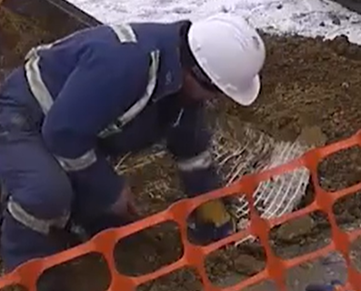
- Expose top of soil cell matrix, and mark position of excavation with marking paint.
- Using a quick cut saw, or portable cutting tool, cut through the soil cell matrix, and remove parts. Alternatively clear soil beneath the bridge connectors in order to be able to release the locking tabs, to re-use the components.
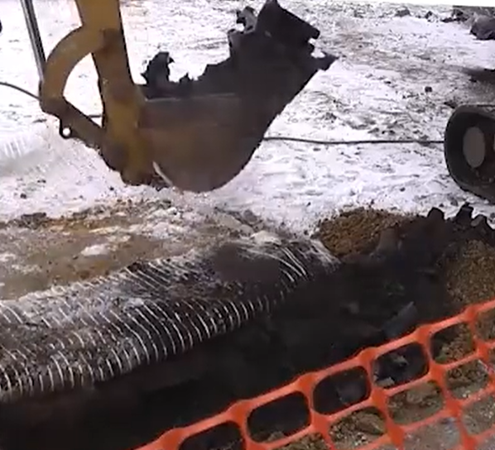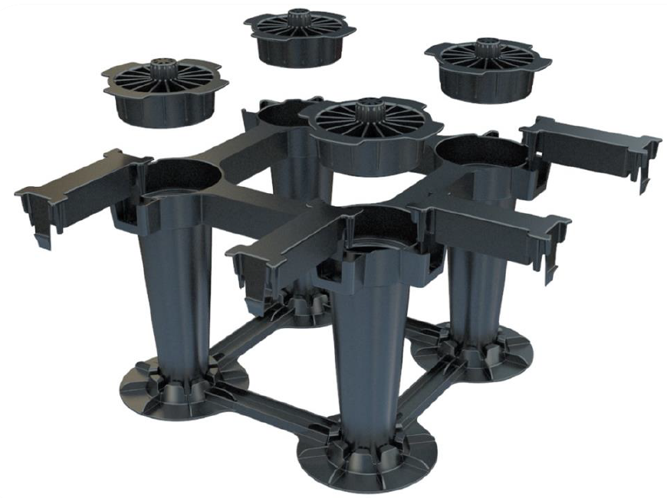
- Remove soil by hand, or mechanically/with hydrovac, to expose further layers of cells. Stock pile this soil for re-use, covered to prevent contamination.
- Repeat process until service is exposed.
- Photograph exposed services, showing area of disassembled cells.
- Repair service.
- Reinstate soil cells by recycling cells where possible or using new components where required.
Also refer https://vimeo.com/album/4210288/video/188245300 - Stratavault assembly (includes cutting cells)
https://vimeo.com/album/4210288/video/188245519 - Stratavault around services.
- Take care to reconnect cells vertically, and laterally where possible, maintaining the correct levels. Note: it may not be possible to reconnect cells to the original matrix, in which case the new structure should be brought as close as possible to the original.

- Refill the matrix with the soil removed, or with an 80:20 Loam soil mixture, to the top of the matrix but no higher, using foot pressure to tamp soil.
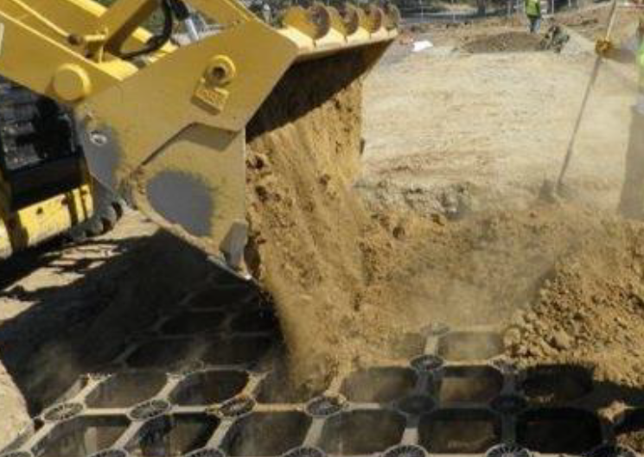
- Reinstate the previously pinned FG3012 Filtergrid geocomposite and place a new piece the same above, overlapping the original layer by 200mm on all sides. Product available from Citygreen Systems.
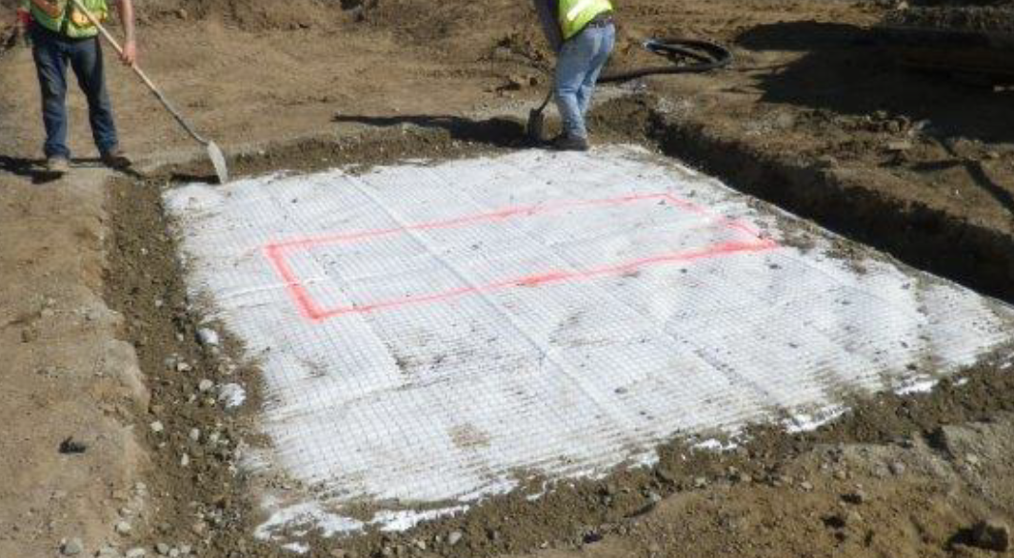
- If time constraints dictate that new material cannot be sourced prior to pavement rectification, reuse the geocomposite removed at point 3 above, and apply a fresh piece of geofabric to overlap the cut by min 200mm in all directions.
- Photograph final reinstated cell matrix area.
- Reinstate granular roadbase to original thickness, compacting in layers of 100mm with plate compactor, to desired thickness.
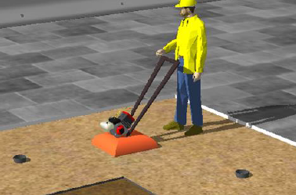
- Reinstate final pavement as required by Asset Owner.

Note: where the pavement is an insitu concrete slab, additional reinforcing may be required by engineers. Allow a lead time of nom two weeks for supply of replacement parts from the supplier. Protect work zone from passers-by while in construction.

The above is a summary; installers of the system should also complete the Citygreen Online Accreditation Course, at no cost.

Appendix B
Warranty

Citygreen™ warrants to the original purchaser of its Citygreen Stratacell™ SC250 product (“product”) and Stratavault™ SV400 product (“product”) that at the date of purchase such product will be of merchantable quality, and perform to Citygreen’s written specifications for the Product for a period of 20 years when the product is installed and used as specifically provided for in the Citygreen installation guidelines for the Product.

This warranty does not apply to normal wear and tear of the product, nor does this warranty apply to the extent that any failure of the Product to comply with any part of the warranty is caused by abuse, misuse, mishandling, improper assembly, unauthorized alterations or modifications to the product, accident, lack of reasonable care of the Product, or failure to install the Product in accordance with Citygreen’s specifications, instructions, manuals and other written material made available to the purchaser of the Product.

For the avoidance of doubt, authorized alterations or modifications to the Product mean the cutting of lateral members of the Product only and provided that such alterations or modifications to the lateral members of the Product have been clearly recorded and documented in Citygreen’s Smart Certify QA system (Smart Certify) and subsequently approved by Citygreen via Smart Certify.

This warranty does not apply to events and conditions beyond the control of Citygreen, including, without limitation, ground subsidence and/or settlement, earthquakes, floods, fire, and other natural events, actions of third parties, acts of God and/or Force Majeure.

In the event of a breach of this warranty, Citygreen will provide a replacement Product. Citygreen will not be liable for incidental costs, including, without limitation, removal of the original Product, delivery, installation of the replacement Product, associated labor and equipment costs, and the cost of, and incidental to, other materials and expenses not covered by this warranty.

Citygreen makes no other warranties, express or implied unless the exclusion of such warranties is prohibited by statute. Citygreen shall not be responsible, either in tort or in contract, for any direct, indirect or consequential damages, loss of profits, loss of revenue, loss of use, or any breach of any express or implied warranty, except where such warranty cannot be excluded by statute.

